Feng Chia University

Electrical Engineering Fundamentals I Lab

Laboratory 12

Rectifiers and Voltage Regulation

Instructor: Prof. Shyan-Lung Lin

Student Name: 周嘉禾

Student ID: D1166506

Experiment Date:29/02/2023

1. Introduction
2. Understand the circuit structure and function of the Rectifier circuits.
3. Understand the circuit structure and function of the voltage regulation.
4. Understand to process to produce a uniform steady voltage from alternating current supply.
5. Materials
   1. DC Power Supply
   2. Waveform Generator
   3. Digital Oscilloscope
   4. Digital Multimeter
   5. Devices

Diode: D = 1N4007 × 4

Resistors: R = 2 kΩ × 1

Capacitors: C = 1 µF × 1

1. Circuit diagram

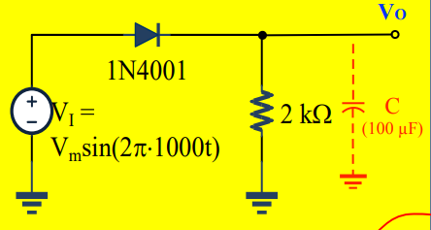

▲ Figure 1. Circuit of Experiment 12.a Half-wave rectifiers

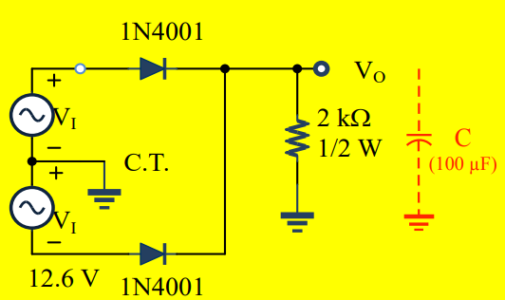

▲ Figure 2. Circuit of Experiment 12.b Full-wave Rectifier – with dual diode

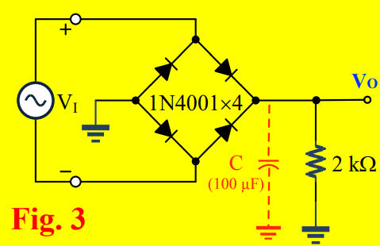

▲ Figure 3. Circuit of Experiment 12.c Full-wave Rectifier with Diode-Bridge

1. Methods

Using Digital Oscilloscope to observe the wave through diode.

1. Experiments data
   1. Experiment 11.a Half-wave rectifiers

normal: 2.8123 V

1 μF: 7.1298 V

* 1. Experiment 11.b Full-wave Rectifier – with dual diode

normal: 5.6147 V

1 μF: 8.0307 V

* 1. Experiment 11.c Full-wave Rectifier with Diode-Bridge

normal: 5.6235 V

1 μF: 8.0349 V

1. Results
   1. Experiment 11.a Half-wave rectifiers

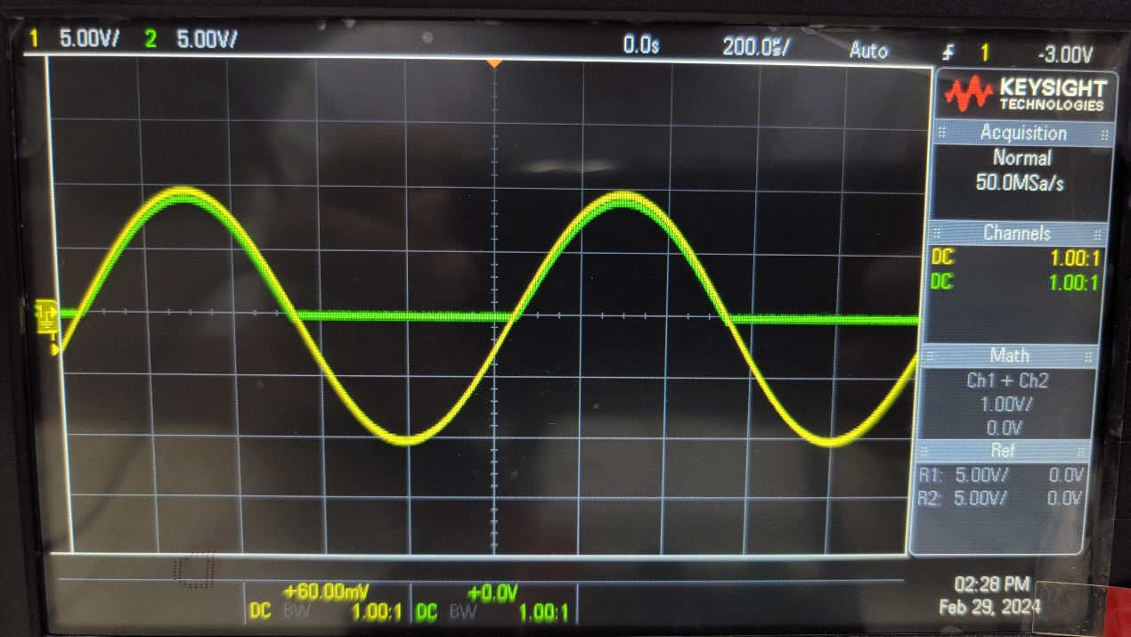

▲ Figure 4. Results of Experiment 12.a without 1 μF capacitor

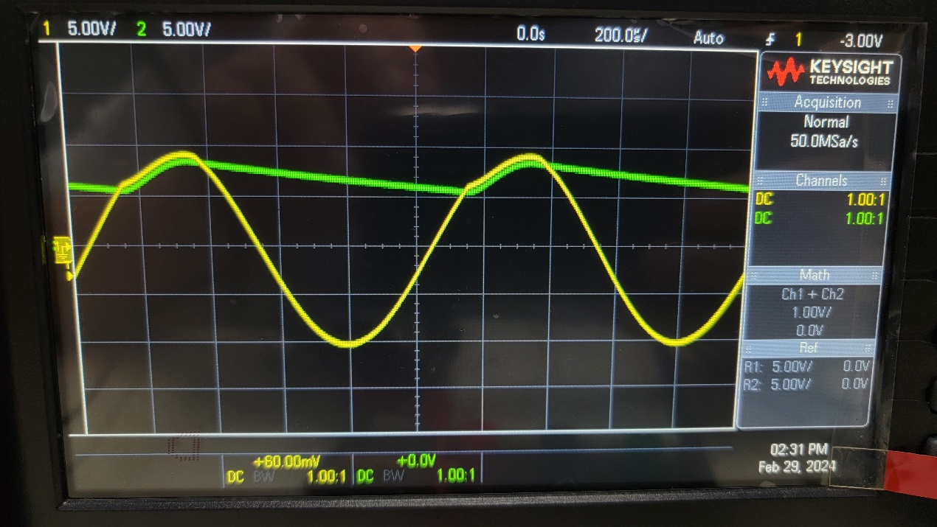

▲ Figure 5. Results of Experiment 12.a with 1 μF capacitor

* 1. Experiment 11.b Full-wave Rectifier – with dual diode

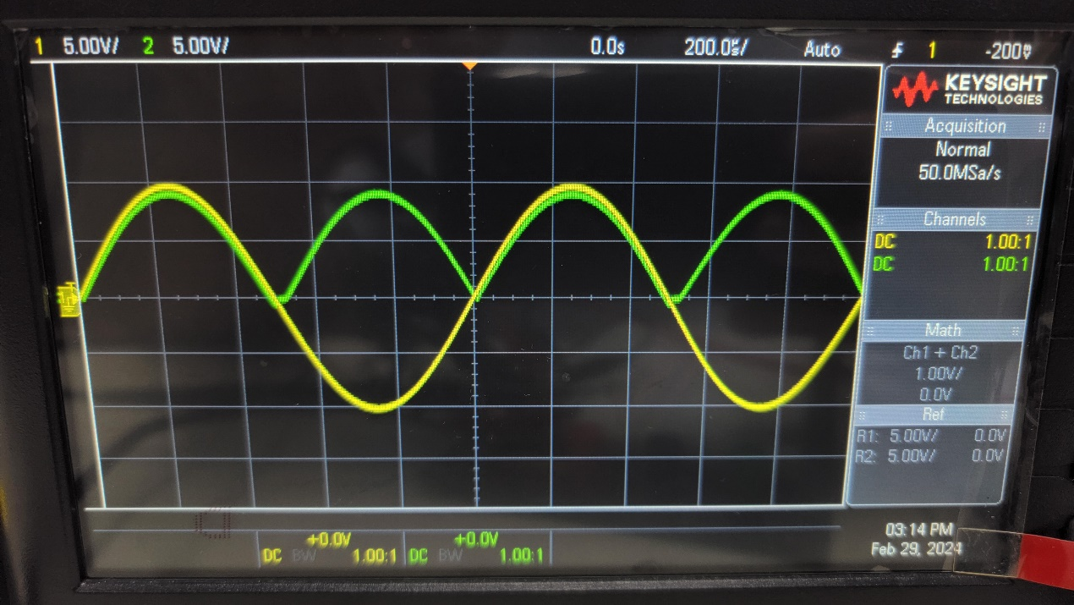

▲ Figure 6. Results of Experiment 12.b without 1 μF capacitor

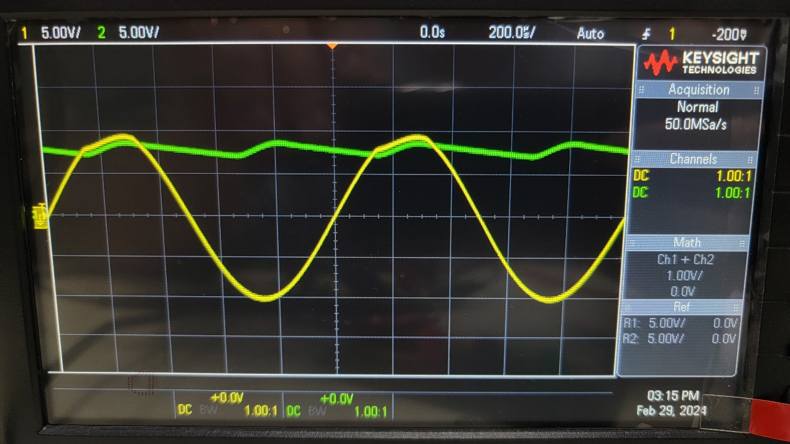

▲ Figure 7. Results of Experiment 12.b with 1 μF capacitor

* 1. Experiment 11.c Full-wave Rectifier with Diode-Bridge

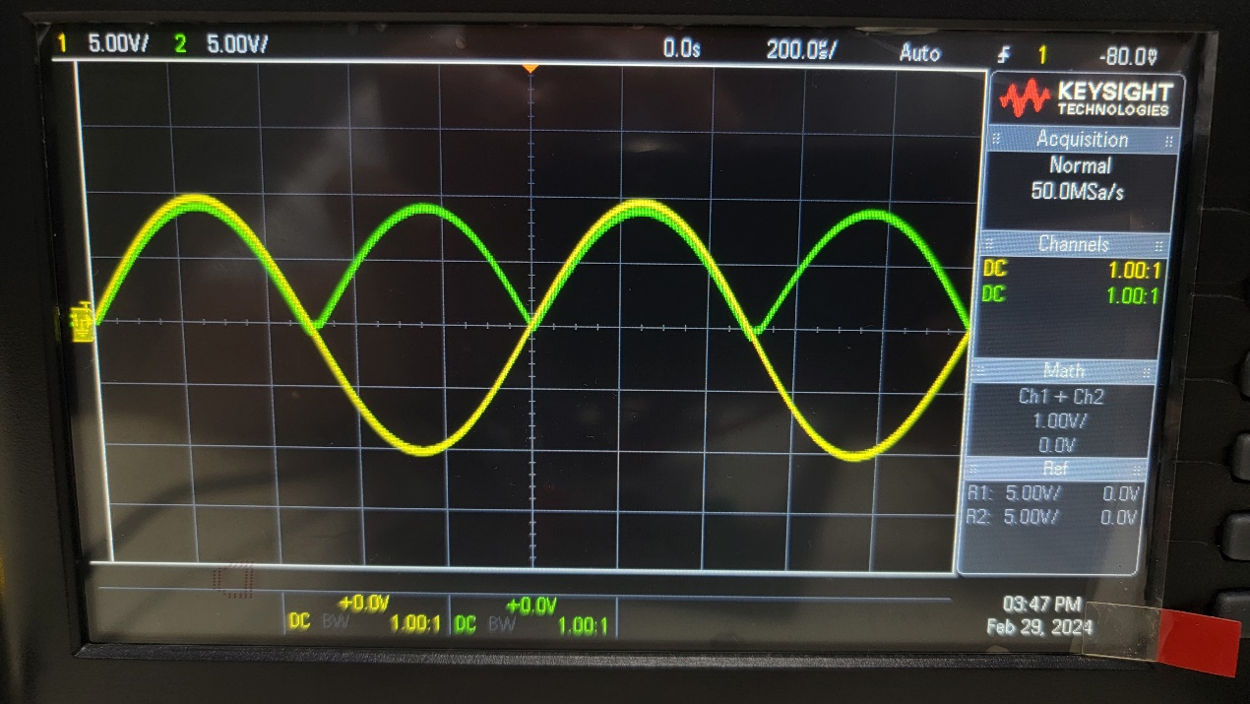

▲ Figure 8. Results of Experiment 12.c without 1 μF capacitor

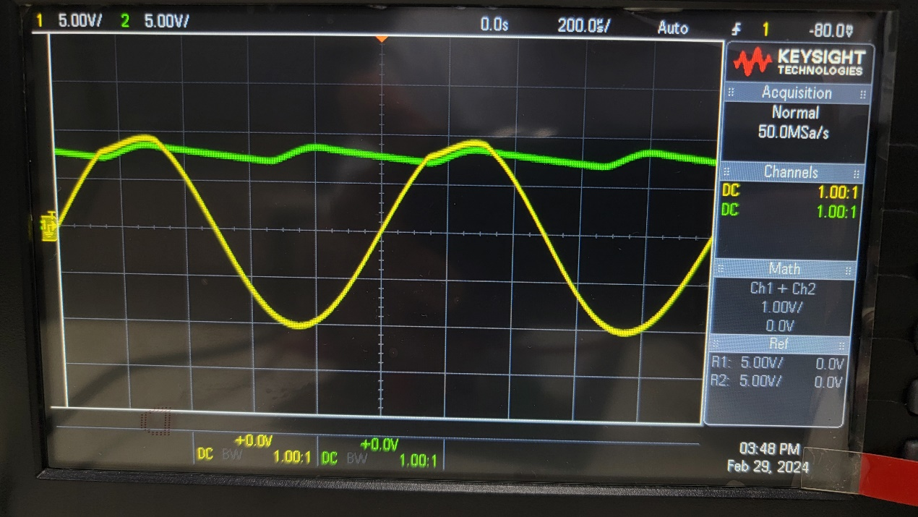

▲ Figure 9. Results of Experiment 12.c with 1 μF capacitor

1. Discussion

In Experiment 12.b, the circuit which asked for a series connection of AC waveform generator, but it can't be complete due to the limit of the machine. Therefore, the problem was solved by adjusting the phaser at the end.

1. Conclusion

In Experiment 12.a, the positive part of the wave can be used, and the wave will become smoother due to the capacitor.

In Experiment 12.b and 12.c, both of them gave the same results that can efficiently use the negative part of the wave and become smoother due to the capacitor, although the way to accomplish them are totally different.